The way to Gwangju, Jeollanamdo from Incheon airport

Arrival in Korea
a) Incheon International Airport - Passport and Immigration Control. To receive official permission to enter the Republic of Korea you will need the following documents: (Do not forget to carry all these documents in your hand luggage!)
- Your valid international passport
- Evidence that you intend to leave the Republic of Korea at the end of the program (normally your round air-ticket will suffice)
b) Customs. After passing through immigration, you will collect your luggage from the Baggage Claim area and proceed to the Customs area. If you have goods to declare, fill out a Customs Declaration form; if you have no goods to declare, you must still go through Customs and notify the Customs officer that you have nothing to declare.
c) Money Exchange. If you have not already changed your money, you should exchange your money for Korean won in any of the Money Exchange booths at the airport. Be sure to have at least 50,000.00(about 50USD) won
exchanged to pay for your bus ticket and meal on the way.

Journey to Gwangju
The express bus from Incheon International Airport to Gwangju Bus Terminal is highly recommended for your convenience. Please be advised there is another city in Korea also named Gwangju. Make sure you are going to the one in Jeollanam-do/Jeolla-do Province.

Bus Trip: Buses run directly from the Incheon International airport to the city of Gwangju. You will need to have on hand approximately 35,000 Korean won (about US$35). The express bus schedule is as follow:
06:50, 07:50, 08:40, 09:20, 10:20, 10:50, 11:20, 12:20, 13:20, 14:20, 15:20, 17:20, 17:50, 18:20, 18:50, 19:20, 19:50, 20:20, 21:20
The bus trip to Gwangju takes approximately four-and-a-half hours. There will be 15 minutes break when the bus stops en route to its destination. Please take note of your bus number when you take a break or get some snacks.

* For more detailed information on the arrival procedure, please refer to Incheon International Airport
website: http://www.airport.kr/eng/
Check the information counter for direction. Don’t be afraid to ask around but be careful of those who you ask. There will be some drivers to offer their car or taxi but that will be very expensive. Travel only by bus. Go out of the airport and find the booth that sells ticket for Gwangju, Jeolla Province. After buying your ticket, proceed to Bus Stop No.9C-10C for the bus to Gwangju (please double check this, there might be new changes).

First Floor Map at International Airport

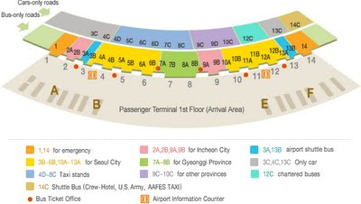
After exchanging some of your US$ dollars to Korean won, you may get out from this gate or 10 A where you will have to cross to the other side.
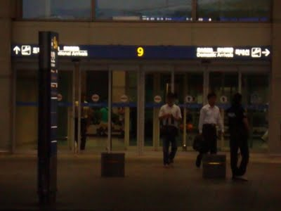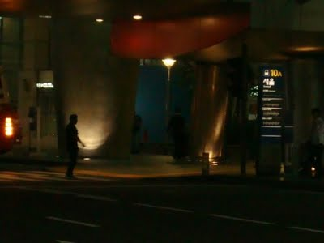
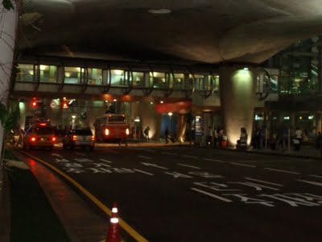
Then purchase your bus ticket at any of the bus ticket booths. Specify and be clear that you are going to Gwangju City in Jeollado or Jeolla Province (there's another City in Kyeonggi Province with the same name). Ticket price (as of writing, a plan to increase public commodities) might cost around 35-40,000 won (US$ 40.00). Ticket will have your seat number, time and other details.
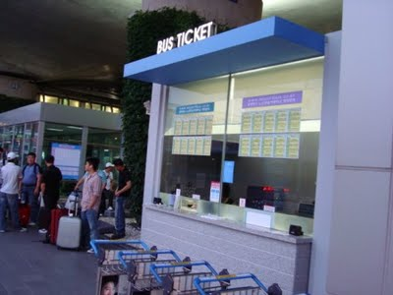
Wait for the bus at this section 9C (double check and ask around if that will still be the designated bus stop when you come) check the destination name Gwangju. Bus will promptly arrive at the designated time and will leave as soon as passengers have all boarded the bus.
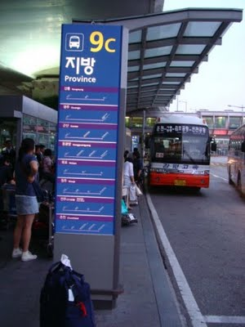
Have a safe journey to Gwangju!
From Gwangju to Green Village(Chosun University dormitory)
After you arrive in Gwangju, Please take a taxi and tell taxi driver like below.
“Drop me off Chosun University: 조선대학교에 내려주세요”

